Evaluating Impact of Stocktwits Sentiment on Investment Trends

Joshua Zweber
Bradley Petersen

Department of Computer Information Science
Minnesota State University Mankato
Professor Mansi Bhavsar
February 12, 2026

Abstract
In our project, we are attempting to see if we can use sentiment analysis from Stocktwits posts to determine stock market trends. Our approach begins by combining 362 fragmented files into 5 separate datasets. Our approach began by dropping non-semantic metadata and categorizing the sentiment data of bearish, and bullish into 1 and –1. Further, we use the FuzzyWuzzy library to remove over 100,000 rows of noisy duplicate and bot driven spam. To test the efficacy of our cleaned data we establish a baseline using a Support Vector Machine (SVM) model, evaluate its success through a confusion matrix, F1 score, and a Matthews Correlation Coefficient (MCC) to set a benchmark for future ensemble model improvements.

I. Approach
We started by downloading the StockTwits_2020_2022_Raw data set from Kaggle [1]. This is a comprehensive repository for sentiment spanning from January 2020 to March 2022. When examining the dataset, the data was fragmented into 362 individual files each containing thousands of features across five different companies including Apple (AAPL), Amazon (AMZN), Meta (FB), Nvidia (NVDA), Tesla (TSLA).
To streamline the workflow and prepare the data for preprocessing, we began consolidating the data. We used pandas' concant function to combine the individual CSV in ascending order from the first post date to the last. And separated the files into five distinct CSV files organized by their associated company. By eliminating the overhead of handling multiple file pointers and establishing a clean and centralized structure for our data.
During our data exploration phase we found some of the raw dataset contained several features that didn’t align with our objectives. Noise in the form of redundant or uninformative metadata can obscure finding meaningful patterns and can increase overhead when processing the data. We performed an assessment of what features were relevant directly to sentiment analysis, and features only relevant to stocktwits internal structure. To refine our data, we removed four specific columns: links, reshares, reshare_messages, and structurable. Links and reshares contain repetitive URLs or boiler plate text and add little to no value when determining Natural Language Processing (NLP). Also, the reshares and structurable provide metadata regarding user interactions and platform formatting that remain outside of the projects' scope for sentiment analysis. By removing these columns, we create a more efficient pipeline for data cleaning.
The next step in our preprocessing was data categorization of the entities column which in our dataset serves as the indicator of the actual user sentiment within the Stocktwits community. The entities column contains two distinct values – bearish and bullish – which we applied numeric encoding to these two primary sentiment values. Comments that express Bullish were positive and assigned a 1; comments expressing Bearish were negative and assigned a –1, creating a clear linear scale to represent investors’ sentiment.
The raw comments from Stocktwits are notoriously noisy, often filled with emojis, special characters, and non-alphanumeric characters. That can interfere with NLP. To make sure that the model only focuses on relevant linguistic features, we implemented a pipeline to strip these away. However, we preserved the use of the ‘$’; in the context of finance, it’s used as a pretext for stocks (e.g. $AAPL or $FB). By keeping the stock symbols while removing extraneous symbols, we maintain the integrity of financial identifiers and remove noise.
A significant portion of the redundancy in our raw data was from low effort posts, more specifically cash tags. For Apple alone, which accounted for 914,962 rows in our dataset, our metrics revealed that the mode commonly removed comment was a simple repetition ticker symbol for their stock $AAPL, which accounted for 27,474 entries. These posts offer little value to our analysis and acted more as noise. By removing these, we were able to thin down the dataset to reflect more substantial user generated comments that provide insight into investor behavior rather than bot driven spam.
To address more redundancies that were more complex, such as typos, or messages that were slightly alterations of the same message. The Fuzzywuzzy library into the duplication workflow. This allows us to scan the rest of the rows for highly similar strings that match filters would typically miss. This approach using simple ticker removal with fuzzy string matching resulted in the removal of 100,658 rows in total. This reduction in volume ensures that our final analysis is grounded in unique perspectives and reduces overactive users or bots skewing the results.
The final stage of our preprocessing we collected temporal features by converted the collection of individual comments into a structured time series format. We sampled the cleaned data set to calculate the average number of posts per hour for each stock. In a 24-hour period, AAPL averaged 98 posts, AMZN averaged 76, FB averaged 109, NVDA averaged 67, and TSLA averaged 207. This allows us to capture the velocity of messages showing us where retail investors are spending most of their attention, enabling a more direct comparison between social media hype cycles and intraday price volatility.
II. Experiments
The main analysis of financial data was based on Stocktwits financial platform. Sharma et al. scraped data from this social media platform and created a dataset [2]. Since this dataset was based on older data and not available to the public, we used a similar collection found on Kaggle [1]. This dataset has scraped general posts, comments, and predicted opinions from the community. There was a total of 362 CSV files included in a combination of 5 major fortune 500 companies including Apple, Amazon, Facebook, Nvidia, and Tesla.
The goal of this dataset is to collect data on user sentiment regarding these companies., and to classify them into bullish and bearish categories. With this dataset, we implemented an SVM model to classify the textual data into categories as a baseline. As mentioned by Sharma et al., several previous SVM models have low accuracy scores compared to other models [1]. The difficulty lies in ensuring the dimensionality of the two bullish and bearish categories. Nevertheless, regardless of these challenges, this team decided to use the SVM as a baseline benchmark for model comparisons. The hypothesis is that the ensemble models built on top of the baseline will significantly improve the accuracy scores over solely using an SVM.
After running the model, we used several metrics to evaluate the performance of the baseline model. First, we used a confusion matrix to examine the number of type I and type II errors within the SVM prediction. The results of the confusion matrix are visualized below.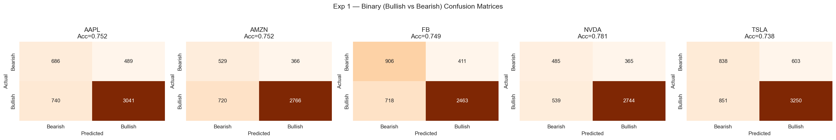
The table also helped us calculate the precision (number of correct “Bullish” responses) and recall (the number of actual “Bullish” responses). Furthermore, with the precision and recall we obtained the F1 score to show the overall accuracy of the predictions. Matthew’s correlation coefficient (MCC) was another excellent indicator alongside an F1 score after the binary classification. To see these equations, please refer to the appendix below.
After running a simple linear SVM model, the accuracy scores for each of the five datasets averaged around .7544. We ran an SVM model with stratified sampling and linearly separable data. This is equivalent to the SVM model score mentioned by Sharma et al. in previous sentiment analysis [2]. From our initial run-through of the SVM model, we tried to also add a third category of “neutral” comments that don’t fit in either category. However, our team quickly discovered that linear separability was not possible for this extra classification scheme. The visualizations and training results showed poor model performance for the SVM model. Going forward, we plan to visualize the model to improve performance and increase its accuracy.
The results of our initial run-through reveal a need for additional fine tuning and visualization going forward. The dimensionality of the datasets significantly impacts the training results of SVMs. Since large datasets are challenging for SVM models, we will split data into multiple amounts of training samples and test each one to find the optimal amount. Furthermore, we will attempt nonlinear strategies such as RBF/Gaussian to split the data into represented margins. Finally, we will continue to use F1 and MCC metrics to lower the number of false positives and false negatives. Since sentiment analysis is an ever-evolving field, there are numerous factors that determine trends in the stock market.

III. Appendix
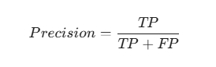
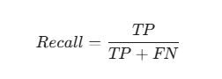
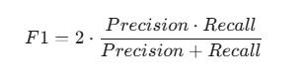
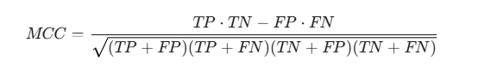

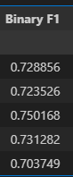
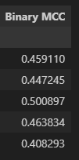

IV. References
[1] F. C. Yun, "StockTwits_2020_2022_Raw," Kaggle, 2022. [Online]. Available: https://www.kaggle.com/datasets/frankcaoyun/stocktwits-2020-2022-raw. [Accessed: Feb. 12, 2026].
[2] N. Sharma, M. Soni, S. Kumar, R. Kumar, N. Deb, and A. Shrivastava, “Supervised Machine Learning Method for Ontology-based Financial Decisions in the Stock Market,” ACM Transactions on Asian and Low-Resource Language Information Processing, vol. 22, no. 5, pp. 1–24, May 2023, doi: 10.1145/3554733.

